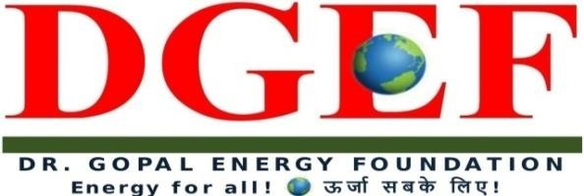
D-GEF Secretariat, JA-121, DLF Tower - A, Jasola District Center, New Delhi-110025, INDIA Tel. :+91-11-26943664, Fax.: +91-11-26970075 24*7*365 Helpline No. +91-8860635075,
Whatsapp No. +91-9810070075 info@dgef.inwww.dgef.in

REGISTRATION FORM
(For Individuals/Professionals/Students) Ref No. DGEF-C-C19-Form B1

The Register
Energy Arbitration- Online Certificate Course

Dr. Gopal Energy Foundation
DGEF Secretary, JA121, Jasola District Centre
NEW DELHI-110025 (India)
Email- registrar @dgef.in Whatsaap- +91-9810070075

Sub- Application for admission to Energy M&A Insolvency Online Certificate Course Awarded By DGEF.
Dear Sir,
I would like to take admission into Energy Arbitration Online Certificate Course. My details are as follows: -
Sl. No. | Details
1 | Full Name
2 | Date of birth
3 | Occupation
4 | Organization/College
5 | Correspondence Address
6 | Mobile Number
7 | Land line Number

College details (only for students)
Sl.No. | Details
1 | Name of the Institution
2 | Course

3 | Year of study

Payment Details
1 | Demand Draft/Check (mention your DD number/check number)
2 | NEFT/RTGS (Mention your Ref number)
2 | Cash deposit (attach the prove of your deposit)
4 | Total amount paid

I submit that all the above information are true and correct and best of my knowledge. I have gone through the by laws of Energy Arbitration online certificate course and undertake to abide by the same.

(Signature)

Completed Form along with Fee to be sent to

Registrar
Dr. Gopal Energy Foundation
DGEF Secretariat, JA-121, DLF Tower- A, Jasola District Centre,
NEW DELHI-110025

Or in alternative
Fax Completed Form to +91-11-26970075 Email scanned copy to: registrar@dgef.in

For any other enquiries, Please contact:
Mr. R. K. Tiwari, Secretary General (CC)
Direct: 91-8860635075 / 91-11-26943664, registrar@dgef.in

