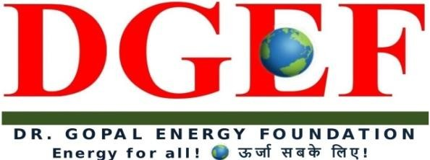
D-GEF Secretariat, JA-121, DLF Tower - A, Jasola District Center, New Delhi-110025, INDIA Tel. :+91-11-26943664, Fax.: +91-11-26970075 24*7*365 Helpline No. +91-8860635075,
Whatsapp No. +91-9810070075 info@dgef.inwww.dgef.in

EXECUTIVE NOMINATION FORM
(For Organizations)

Ref No.DGEF-C-C19-Form B2

The Register
Energy Arbitration- Online Certificate Course

Dr.Gopal Energy Foundation
DGEF Secretary, JA121, Jasola District Centre
NEW DELHI-110025 (India)
Email- registrar @dgef.in WhatsApp No. +91-9810070075

Sub- Nomination of Candidates for Energy M&A Insolvency Online Certificate Course Awarded by DGEF.

Dear Sir,
The following officials/Executives are nominated for Online Certificate Course on Energy Arbitration Laws from our organization:

S. No. | Name | Designation | Email id | Mobile no | DOB
1
2
3
4
5
6
7
8
9
10

11
12

Nominating Authority |  | Designation
Organization |  | Address
Tele / Fax |  | Email
Amount Paid  (For Energy Arbitration online  certificate course) |  | Mode of Payments
Total Amount Paid

(Signature with company stamp)

Completed Form along with fee to be sent to:

Registrar
Dr. Gopal Energy Foundation
DGEF Secretariat, JA-121, DLF Tower- A, Jasola District Centre, NEW DELHI-110025

Or in alternative
Fax Completed Form to 91 11 26970075 Email scanned copy to registrar@dgef.in For any other enquiries, please contact: Mr. R. K. Tiwari, Secretary General (CC)
Direct: 91-8860635075 / 91-11-26943664, registrar@dgef.in

